Voltage Derating Curve

Measurement Categ。叩|

Oscilloscope Probe Kit
Model. P6501

V"、4
(Vrms)
 |  |  |  |  | 飞
 |  |  |  |  |  | 网 |  | 、
 |  |  |  |  |  |  |  | \

CE
600 V

500 V

400V

300V

200V

100 V

OV

10KHz 1∞KHz
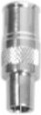

1MHz 10MHz

Fig.1

1ωMHz 1GHz
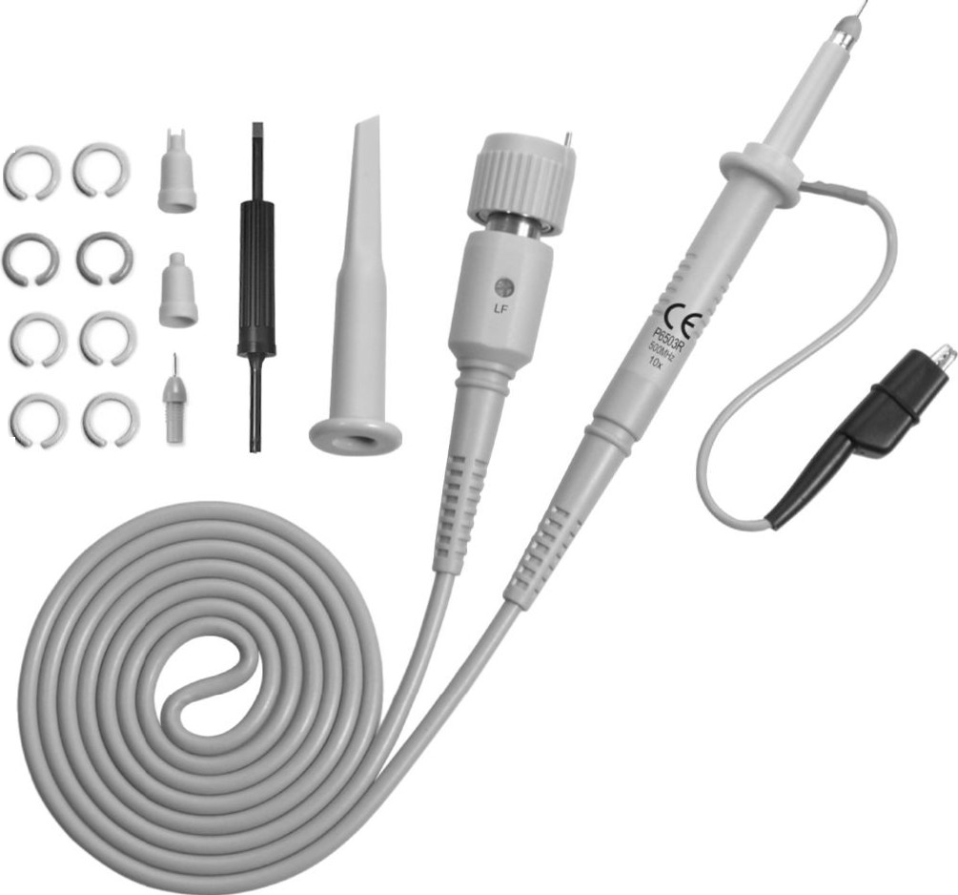

Made in Taiwan
•
n
/''
tt，BEEt 、
EE--
Accessories Description Channel Identifier Clip Sprung Hook
Ground Lead
Insulating Tip ICTip Adjusting Tool Measuring Tip
Sprung Earth Tip BNC Adapter

Part No.
PA-105 x4 Colors PA-106
PA-107 PA-108 PF-902 PA-606A PA-102A PF-905A PF-901
Version:HF-J0101B

)t

Introduction
The P6501 is a passive high impedance oscilloscope probe designed and calibrated for use with instruments
having an input impedance of 1 M (2 shunted by 13pF.
However，it may be compensated for use with instruments having an input capacitance of 8 to 20p F.
1..

H.F.Compensation Adjustment
The probe high frequency (H.F.) compensat ion should seldom require
adj ustment; however，if adjustment is required，use the following procedure.
Connect the probe to a 1MHz square wave (rise time less than O.7nS)，
and adjust the oscilloscope controls to display one half cycle of the waveform. adjust the H.F.trimmer located in the BNC plug for a flat

oscilloscopes that automatically detect probe attenuation and adjust the scale readout accordingly .
， 咱 A
、
'
、
，I_

Safety Instructions

Review the following safety precautions to avoid injury and prevent damage to this product or any products connected to it.
• To avoid potential hazards ，use this product only as specified .
• The common terminal is at ground potential. Do not connect the
common terminal to elevated voltages .
- Do not operate in an explosive atmosphere .
- Keep product surfaces clean and dry.
- If your probe requires cleaning ，disconnect it from the instrument and clean it with mild detergent and water . Make sure the
probe is completely dry before reconnecting it to the instrument.

Compensation Adjustment
The following adjustment is required whenever the probe is transfer red from one oscilloscope or input channel to another.
Connect the probe to the oscilloscope ，apply a 1KHz square
wave to the probe tip ，or connect to the cal socket on the oscilloscope to display a few cycles of the waveform and adjust
the trimmer located in the BNC plug for a flat topped square wave.
、吨，，
‘，
，『
1..
咱

Specifications

Attenuati on Ratio Bandwidth
Rise Time
Input Resistance

Input Capacitance Compensation Range Max. Input Voltage

Pollution Degree Operating Altitude
， ，A
，
，
晴h 、
|、
，
咱 ，

10:1
DC to 500MHz 0.7nS
10MO w hen used with oscilloscopes
which have 1MO input.
Approx . 11pF 8 to 20pF
Measurement Category 1: 500 Vrms， (see voltage derating curve on Fig.1)
Measurement Category 11: 400 Vrms

Pollution Degree 2 (as defined in EN 61010-031)
UP to 3000 meters

、、，'
、，
'、、，' A
.-. 咱、I ，
4
--3，

Humidity

5% to 95% RH (100 C to 300C)
5% to 75% RH (300 C to 400C)
5% to 50% RH (above 400 C)

，、 、 ，
，I
，、 ，『、 、 ，

Cable Length

RH not controlled below 100 C
1.2 Meter

，4 、、
A 、 、，
、 、，

